How-to Register for Paragon Academy
Step 1: Visit this site and click on “Sign up here!” to register.
- Use this site to register AND log back in at any time.
https://blackknight.gmetrix.net/Login.aspx?ReturnUrl=%2F

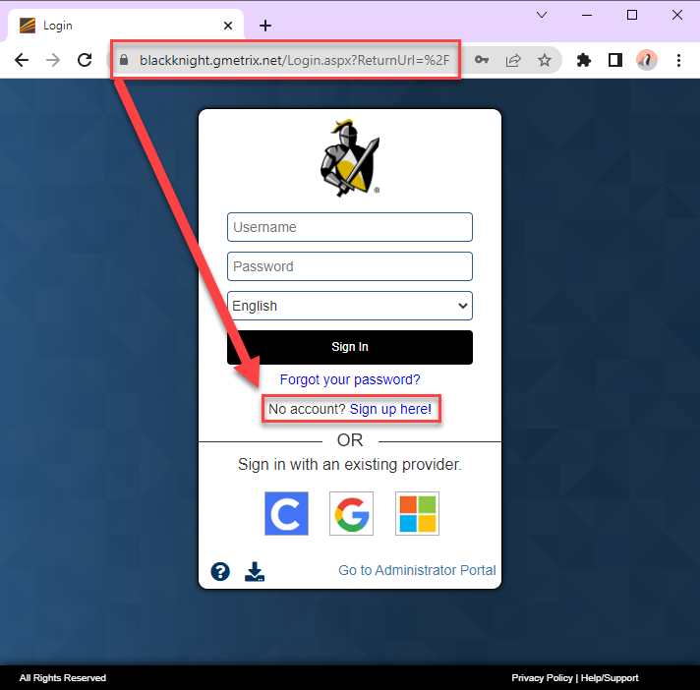
Step 2: After clicking on “Sign up here!”, complete all of the “User Registration” information. “Student Number” is NOT required.

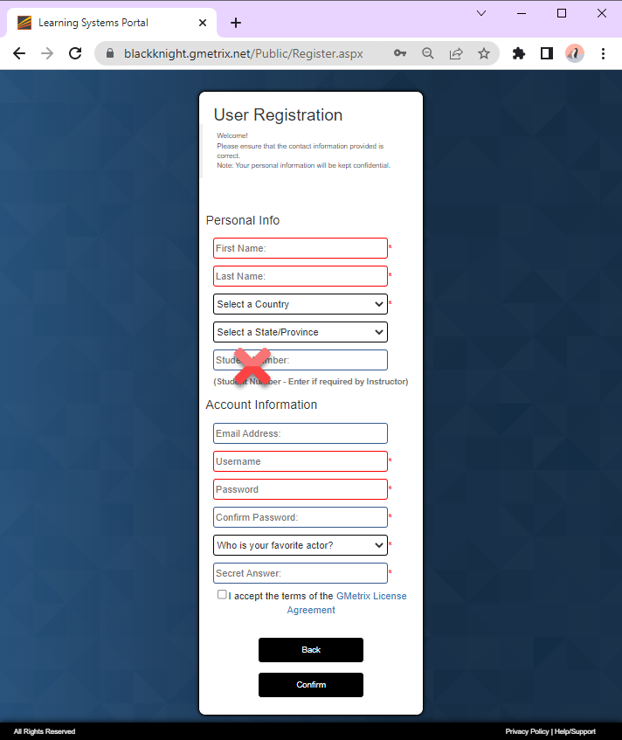
Step 3: Once form is filled out, accept the terms and then click on “Confirm”.
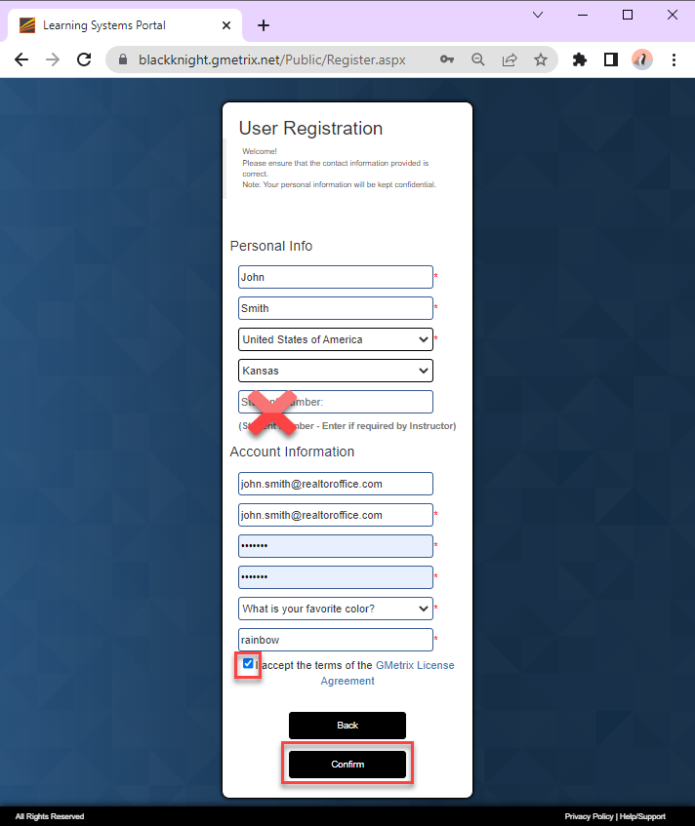

Step 4: After account is created, a “Success!” confirmation message appears.
Now the user can sign in with the credentials just created.
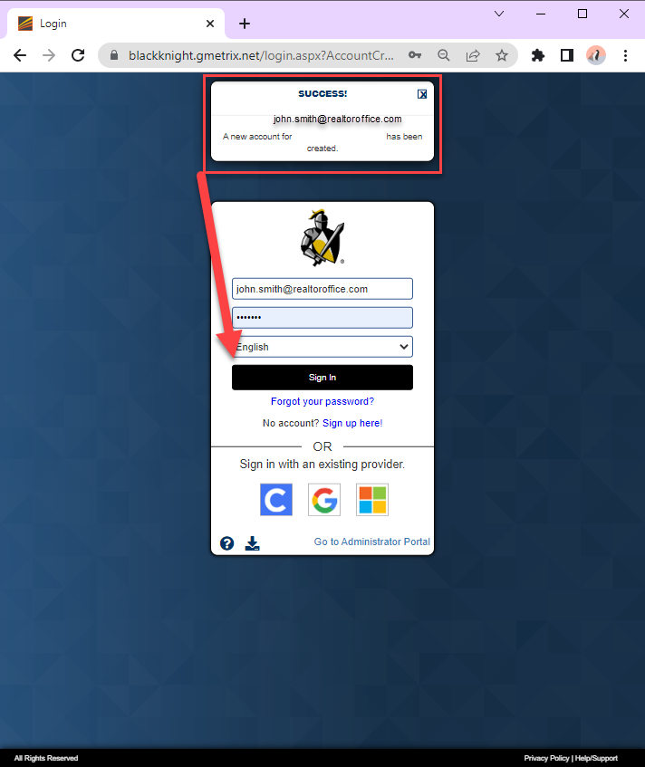
Step 5: Add Paragon Academy to your courses with the access code.
The access code can be found on our help site:
https://help.paragonrels.com/Overviews/MLS_Paragon_Academy.htm
If the “Redeem” box does not appear upon login, click on “Redeem” in the menu to find the access code box. You will find the access code on our helpsite.

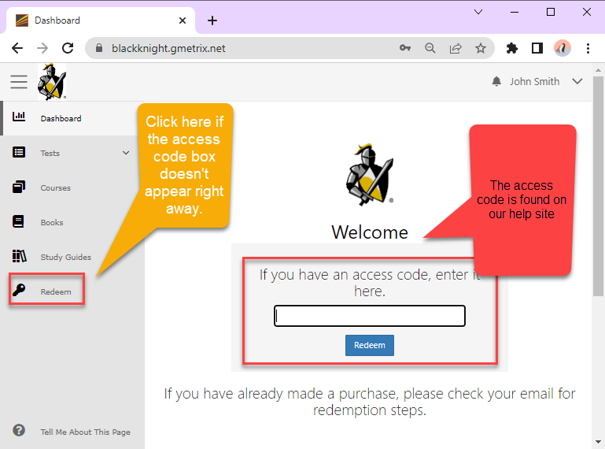

Step 6: Click on a course to begin. Users will receive a certificate for completing each course.
The Access Code will register the user for all Paragon courses available.
Users should check with their MLS/Board/Association/Organization to see what courses are required for their group. All courses are offered for free to all users!
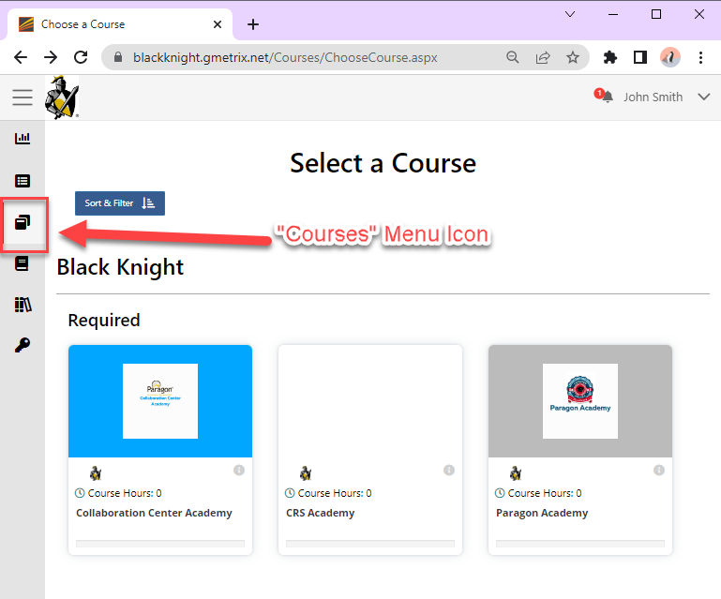

Step 7: Click on your name at the top and then “Log out” when you are done.
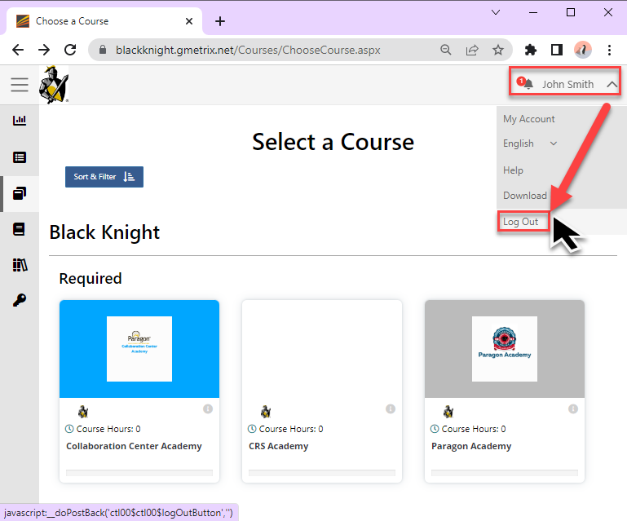

Step 8: After logging out, users are returned to the “Sign In” screen.
Bookmark this URL to use this to log in again at any time.
https://blackknight.gmetrix.net/Login.aspx?ReturnUrl=%2F

